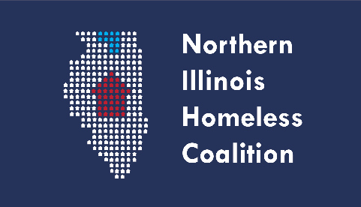 **Full Membership Meeting Minutes**

**Date:**  Thursday, March 16, 2023

**Time:** 3:00 PM – 4:30 PM

**Location: NIHC Returned to In-Person Meetings. Virtual option listed below.**

Winnebago County Health Department

Room 115

555 N. Court Street, Rockford, IL 61103

Note: Masks required at all times. HEPA filters cleaning the air in the meeting room as an additional layer of mitigation. Distant seating arrangement due to COVID protocol

**Present:** Kira Devin, Kelci Cox Raney, Joyce Williams, Jennifer Yochem, Mike Hedrick, Cassandra Barnett, Angela Wood, Dani Alexander, Emily Schwartz, Paula Lind, Olga Ivari, Christina Wirsing, Elizabeth Cardenas, Sarah Parker, Melissa Crowell

**Agenda Items:**

1. Welcome and Introductions – 3:01 pm
2. Review of Mission statement
   1. Moving forward, the mission statement will be read at each meeting
3. February Meeting Minutes Approval
   1. 1st – Kira; 2nd – Mike – unanimously approved
4. By-Laws (Governance) Report – Paula
   1. Kira and Paula met to review the By-laws
   2. Discussed potential amendments to the sections of Open Meetings Act, Scoring and Ranking Committee and Record Retention
   3. Todd and Paula will meet next week to work on By-laws, proposed amendments will be presented at the April meeting
5. HMIS Lead Agency
   1. Work on the data migration to the new system
   2. Provided a presentation of clarification to involved agencies
   3. 3/31 is last date of access, reach out to Joyce if you need assistance
   4. Building robust training site for COC website, sharing documents
   5. Entering data for HUD
   6. Angela inquired if all agencies were included in the email communication and trainings.
      1. Joyce clarified that it was the agencies in IL. WI agencies are on a different system
6. Treasurer’s Report - $1,740.67
   1. $4 monthly withdrawal
   2. $100 check for SHPA dues cleared
7. Committee Updates
   1. Coordinated Entry – no update
   2. Built for Zero (formally Chronic Homeless) – no update
   3. Membership, Ed & Public Relations
      1. Membership Renewal Forms
         1. Only 5 agencies have turned in their membership forms, please turn in your forms to Susan Rader. Membership forms need to be submitted even if you aren’t scheduled to pay dues
      2. PR is working on Domestic Violence training, hoping to have more information at next month’s meeting
   4. Equity and Diversity
      1. **Register for the in-person April 18th DEI Seminar by March 22 - complete this form** [**https://forms.office.com/r/tQsq9rPLVV**](https://forms.office.com/r/tQsq9rPLVV)
      2. Location address is on the registration form
      3. Cherry Valley Library is booked for the date of training
      4. Reached out to Community Center in DeKalb and is able to meet all of our needs, booked the facility for 4/18
      5. No need for volunteers, the facility will take care of set up and tear down.
      6. $30 for attendance
         1. If an organization is unable to pay the registration fee, that is ok. Check no on the form and it will be covered. We want all NIHC members to attend
8. COVID-19 Update
   1. Winnebago County has had an uptick of cases to medium, to protect yourself and family it is encouraged to wear a mask in public
9. Agency Updates/Announcements
   1. VA Grant Per Diem – Case Manager position open at Rosecranse
   2. Housing Advocate position open at Shelter Care
   3. Jubilee Center will have showers available, also have washer and dryers for use for Jubilee members
   4. PIT unsheltered – 65
10. Adjournment – 3:24
    1. 1st – Kira; 2nd – Mike – unanimously approved