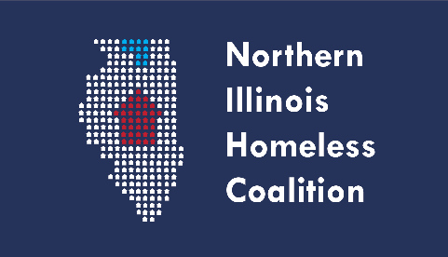 **Full Membership Meeting Agenda**

**Date:**  Thursday, March 16, 2023

**Time:** 3:00 PM – 4:30 PM

**Location: NIHC Returned to In-Person Meetings. Virtual option listed below.**

Winnebago County Health Department

Room 115

555 N. Court Street, Rockford, IL 61103

Note: Masks required at all times. HEPA filters cleaning the air in the meeting room as an additional layer of mitigation. Distant seating arrangement due to COVID protocol

Northern Illinois Homeless Coalition Meeting  
Thursday, March 16, 2023: 3:00 PM – 4:30 PM  
**Remote Option:**Join Zoom Meeting

<https://us06web.zoom.us/j/89980199197?pwd=b1pBbkNjTjg3YW9iOTRDakQyWU0zZz09>

Meeting ID: 899 8019 9197

Passcode: 763542

**Agenda Items:**

1. Welcome and Introductions
2. February Meeting Minutes Approval
3. By-Laws (Governance) Report - Paula
4. HMIS Lead Agency
5. Treasurer’s Report
6. Committee Updates
   1. Coordinated Entry
   2. Built for Zero (formally Chronic Homeless)
   3. Membership, Ed & Public Relations
      1. Membership Renewal Forms
   4. Equity and Diversity
      1. **Register for the in-person April 18th DEI Seminar by March 22 - complete this form** [**https://forms.office.com/r/tQsq9rPLVV**](https://forms.office.com/r/tQsq9rPLVV)
7. COVID-19 Update
8. Agency Updates/Announcements
9. Adjournment