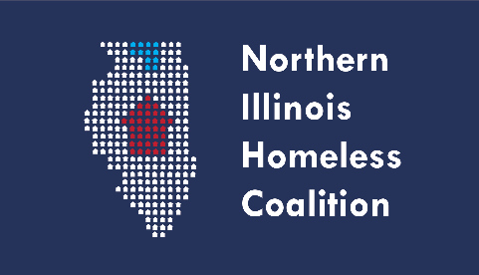 **Full Membership Meeting Agenda**

**Date:**  Thursday, May 18, 2023

**Time:** 3:00 PM – 4:30 PM

**Location: NIHC Returned to In-Person Meetings. Virtual option listed below.**

Winnebago County Health Department

Room 115

555 N. Court Street, Rockford, IL 61103

Note: Masks required at all times. HEPA filters cleaning the air in the meeting room as an additional layer of mitigation. Distant seating arrangement due to COVID protocol

Northern Illinois Homeless Coalition Meeting  
Thursday, April 20, 2023: 3:00 PM – 4:30 PM  
**Remote Option:**Join Zoom Meeting

<https://us06web.zoom.us/j/89980199197?pwd=b1pBbkNjTjg3YW9iOTRDakQyWU0zZz09>

Meeting ID: 899 8019 9197

Passcode: 763542

**Agenda Items:**

1. Welcome and Introductions
2. Review of Mission Statement
3. April Meeting Minutes Approval
4. HMIS Lead Agency
5. Treasurer’s Report
6. Committee Updates
   1. Coordinated Entry
   2. Built for Zero (formally Chronic Homeless)
   3. Membership, Ed & Public Relations
   4. Equity and Diversity
7. COVID-19 Update
8. Agency Updates/Announcements
9. Adjournment