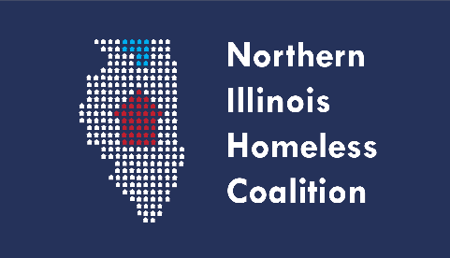 **Board Meeting Minutes**

Thursday, April 6 · 3:00 – 4:30pm

**In Person Location:**

Room 115

Winnebago County Health Department

555 N. Court St., Rockford, IL 61103

**Remote Option:**

Zoom Meeting  
[https://us06web.zoom.us/j/89656947564?pwd=Y205N01CdVQzNHVFYnN4VHJDMGxSQT09](https://www.google.com/url?q=https%3A%2F%2Fus06web.zoom.us%2Fj%2F89656947564%3Fpwd%3DY205N01CdVQzNHVFYnN4VHJDMGxSQT09&sa=D&ust=1663615800000000&usg=AOvVaw1ui8iz1_Umo9K8_IEPFq7b)

Meeting ID: 896 5694 7564  
Passcode: 281254

**Board Members:**

**Present:** Michael O’Connor, Kira Devin, Angela Wood-Zuzevich, Heather Beaufils,Todd Kisner, Paula Lind, David Siegel, Jennifer Yochem, Lesly Wicks, Sarah Parker-Scanlon,

Melissa Crowell, Emily Schwartz, Angie Walker, Adam Smith, Owen Carter

1. Welcome, Roll Call, and Introductions
   1. Call to order – 3:05 pm
2. Review of Mission Statement
   1. Kira read mission statement
3. Approval of Meeting Minutes from March
   1. 1st – Kira; 2nd – Angela; unanimously approved
4. Revised By-Laws (Paula)
   1. Todd and Paula met to review the By-Laws, last reviewed 2/2022 with review of DEI
      1. Highlighted areas are the revisions
      2. Page 6, Section 3
      3. NIHC – 4th bullet
      4. Amendment change: NOFA to NOFO
   2. Motion to approve By-Laws
      1. 1st – Paula; 2nd – Sarah; unanimously approved; motion caries
5. Announcement of FY2022 CoC Awards (Angie)
   1. Congratulations to Shelter Care
   2. Unfortunately, Carpenter’s Place was not funded
      1. Met with Mike to brainstorm ideas
      2. Some clients might come to Rockford Township, a couple have already
   3. Adam – HUD has not funded some tier 2 projects in other communities as well
   4. HUD did not change FMRs
6. Collaborative Applicant Report
   1. Provided quarterly update sent out with the meeting documents
   2. Yearly update from last year, which included April numbers
   3. Attended conference
      1. HUD will be putting out three different NOFOs
   4. Men’s Crisis has been full
   5. Unsheltered numbers are going up; there were 10 people the last time staff was out
   6. Coordinated Entry Committee – training for the COC, planning in the next few months; sending training to Board for approval
   7. Spending of the State ESG information sheet
7. HMIS Lead Agency
   1. Live with the new database – Clarity
   2. Reminders to users, don’t use the old database; only enter new clients and the data will be migrated
   3. Only users who have gone through training will be able to use the new database
      1. Files can be merged if there is a double-entry
      2. Notes do not transfer, have a copy of the notes and will be sent over
      3. Attachments will also not transfer, copies can be sent to users
   4. Currently have 18 users which is half of the users
   5. If you need reports, just let Joyce or Adam know
8. Treasurers Report
   1. Balance - $1740.67
9. COVID-19
   1. May 11th is when COVID expires; IL considers it to be reportable disease; continues to fluctuate, continue to have good hand hygiene
10. Agency Announcements
    1. DEI training – finalized
    2. Attempted to get copies of the slides
    3. 16 people registered, encourage attendance
    4. Prairie State Legal is down three lawyers, if you have questions send Kira an email
    5. Membership due – Emily will reach out to Sue on
11. Adjournment – 3:48 pm
    1. 1st – Kira; 2nd – Angie; unanimously approved